**SOAP to REST Scenario**

**Pre- requisite to start this development-**

**Enterprise Service Repository** - Software Components defined for Sender and Receiver System.

**Business Logic behind this development**

Sender system will trigger a message from Soap UI to PI.

PI will perform the basic transformation/mapping.

PI will post the request data to ret receiver URL and get the response.

**Design**

**Access to the Process Integration Tools:**

Link provided

<http://in-mum-solman:50000/dir/start/index.jsp>



**2. Access Enterprise Service Repository (ESR):**

Click on the link Enterprise Service Builder under Enterprise Service Repository. The following

Screen appears –



Login to PI using your user id and password.

**3. Import the software component define in SLD:**

**FYI: If Software Component is already imported please ignore this step.**

Import the following software component defined for the scenario into ESR

CAPGEMINI_TRAINING_DEMO, 1.0 of Capgemini

Click on new under object and select SWCV under Work Areas.



Click on Display and select the required sender and receiver business system to be imported into ESR for further development

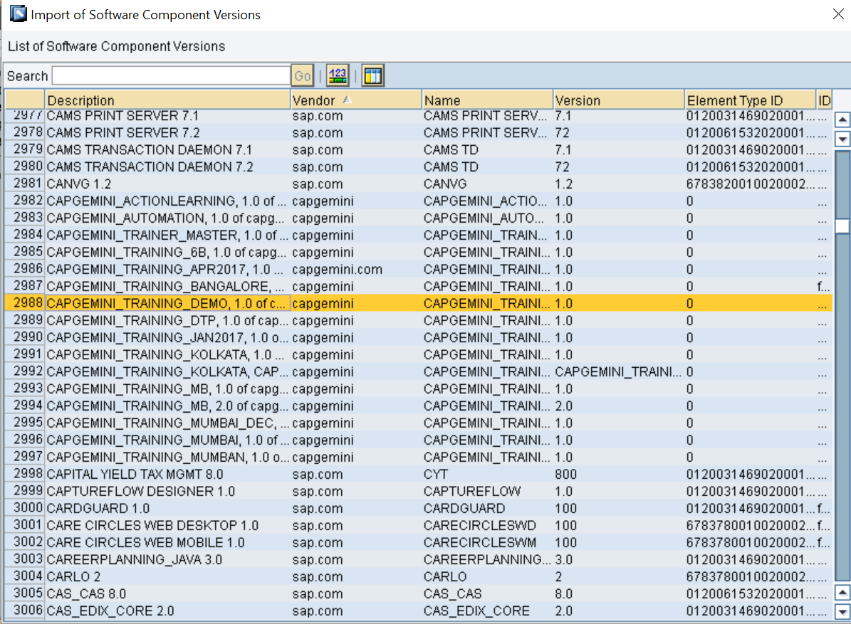

**4. Define Namespace**

You Define a Namespace for you SWCV that uniquely identifies all the objects you create in Repository.

Right click software component version and select Namespace from the context.

Create the following namespace

http://Capgemini.com/SoaptoRest_<<**last three digit of employee ID>>**

After creating and saving it appears like –

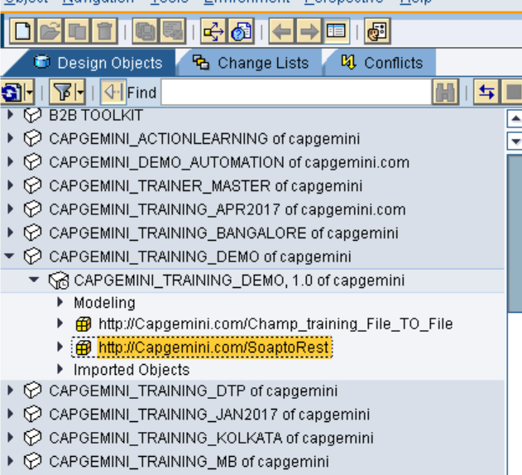

**6. Define Data Type**

Date type (DT_Request_<Name/EmpNo> for sender system.

Date type (DT_Response_<Name/EmpNo> for sender system.

Create data types with required structure and type of elements as shown below.

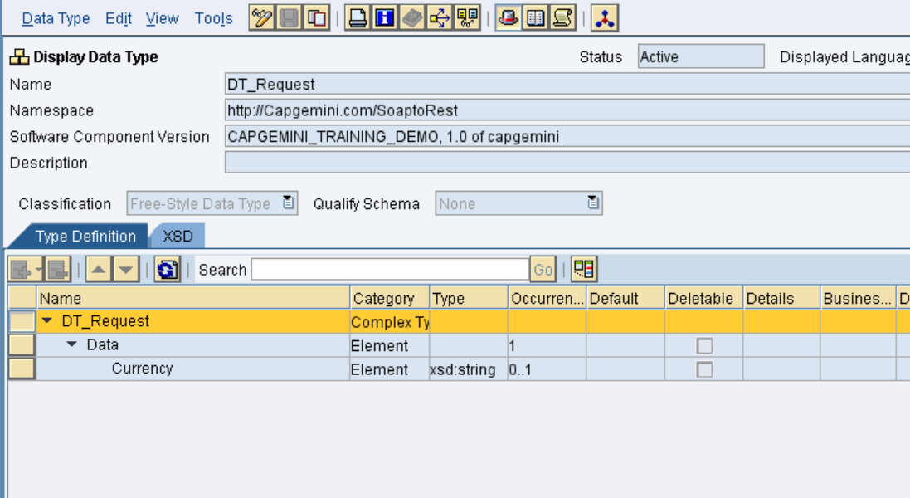

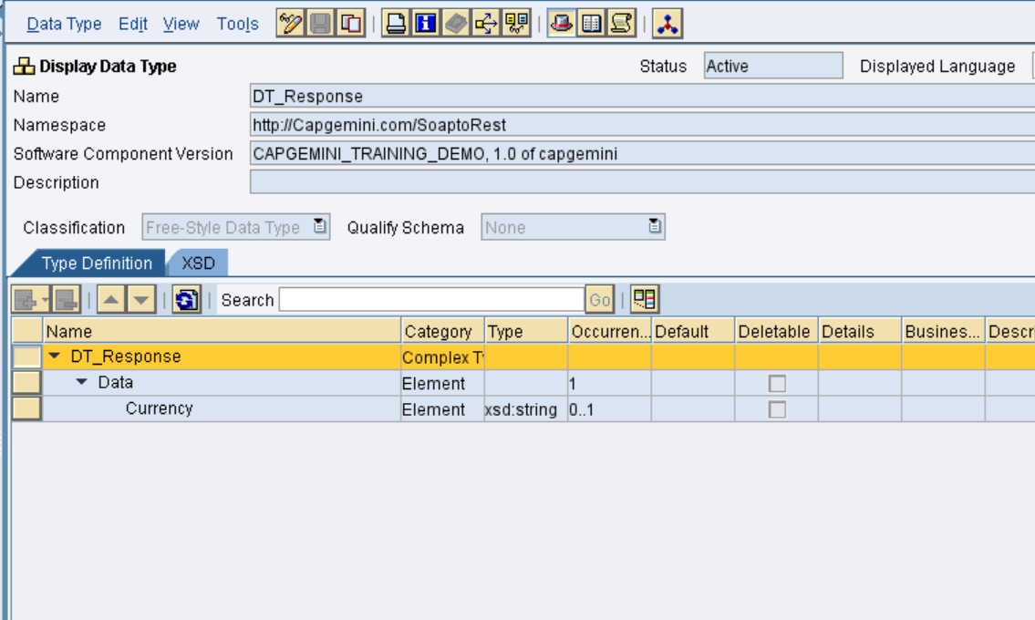

**7. Define Message Type**

Message type (MT_Request_<Name/EmpNo> for sender System

Message type (MT_Response_<Name/EmpNo> for receiver System

Select the Data type (created in the previous step) for the message type. The Namespace automatically gets populated. This is the message type for receiver system. Save after completing.

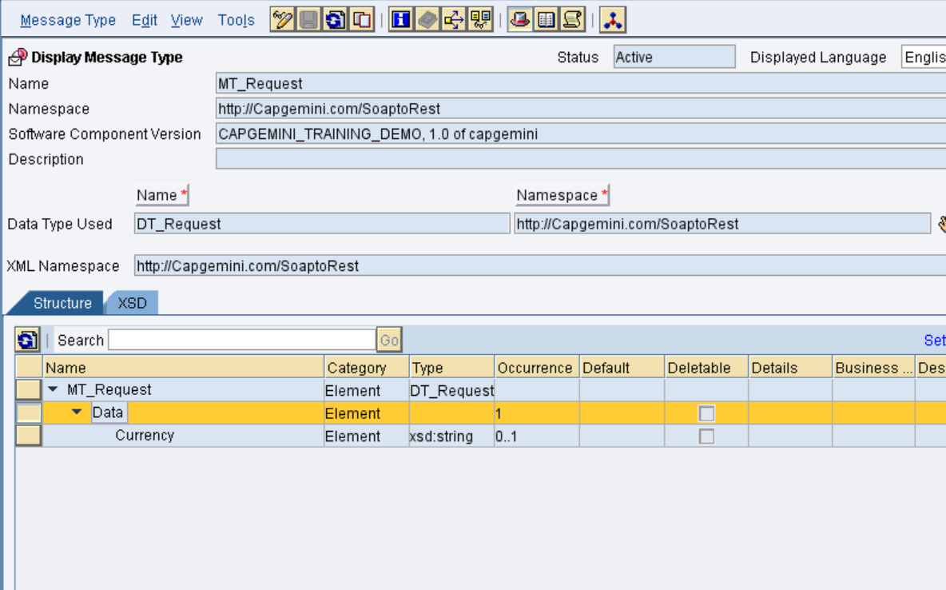

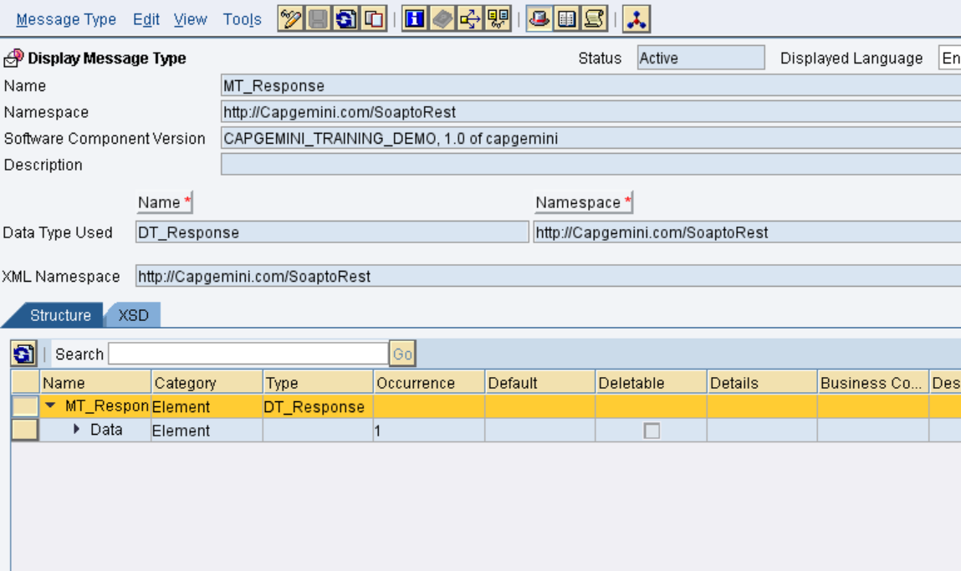

**Create Service Interfaces**

Service Interface (SI_Out_Syn_< Name/EmpNo> ) for sender System.

Service Interface (SI_In_Syn_< Name/EmpNo>) for receiver System.

This is the service interface for the receiver system. Save after completing

For sender system:

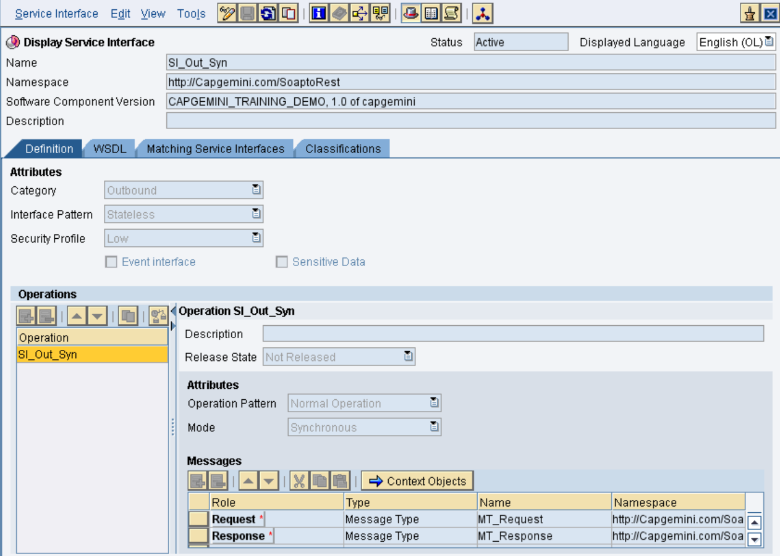

For receiver system:

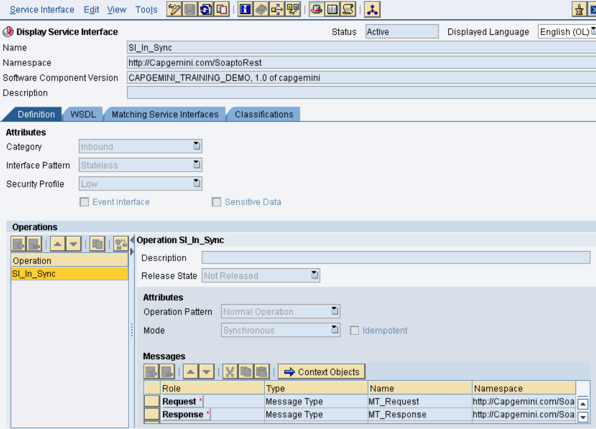

In the above snap in MODE operation we having 2 Types:

Asynchronous- One way message flow (Sender to Receiver)

Synchronous- two way message flow (Request and Response)

This is synchronous flow, we are using Quality of service as BE (Best Effort).

**9. Create the Message Mapping**

Create a new Message mapping MM_Request_<Name/EmpNo>

Create a new Message mapping MM_Response_<Name/EmpNo>

The mapping in this scenario is one-to-one. The names of the source field and target fields are identical. To perform a mapping, drag the source fields and drop on the target field. The mapping would be displayed in the graphical display

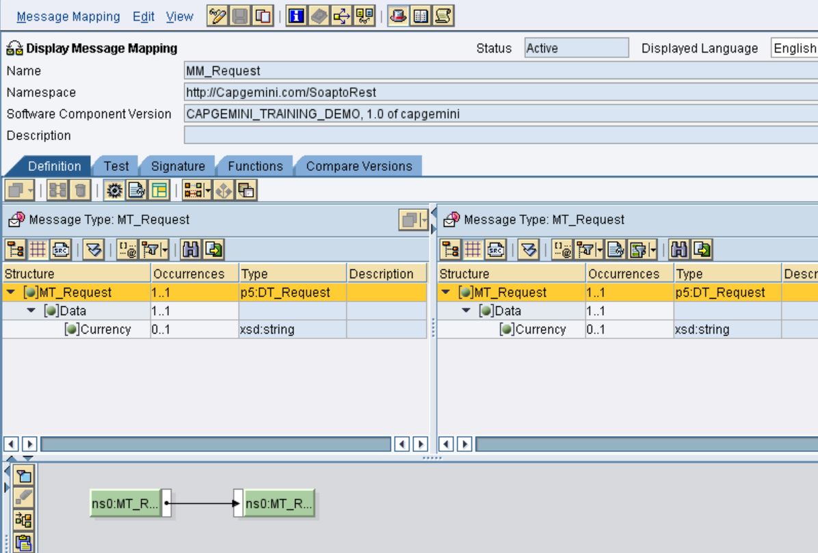

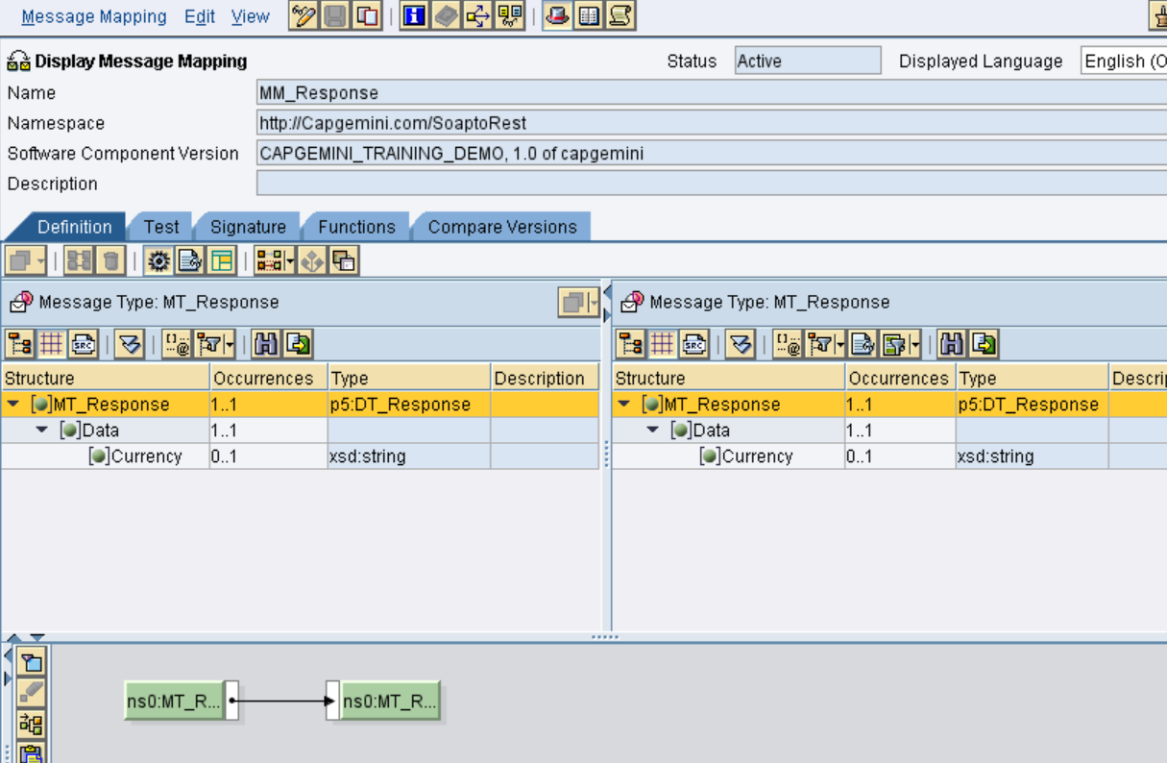

You can test you mapping by going to test Tab. You can select either of the two buttons from

The tool bar to test your scenario.

1. Load XM Instance load an XML file that contains your test data.

2. Generate Instance by specifying the value manually.

Now you can test the scenario by clicking the Execute Mapping.

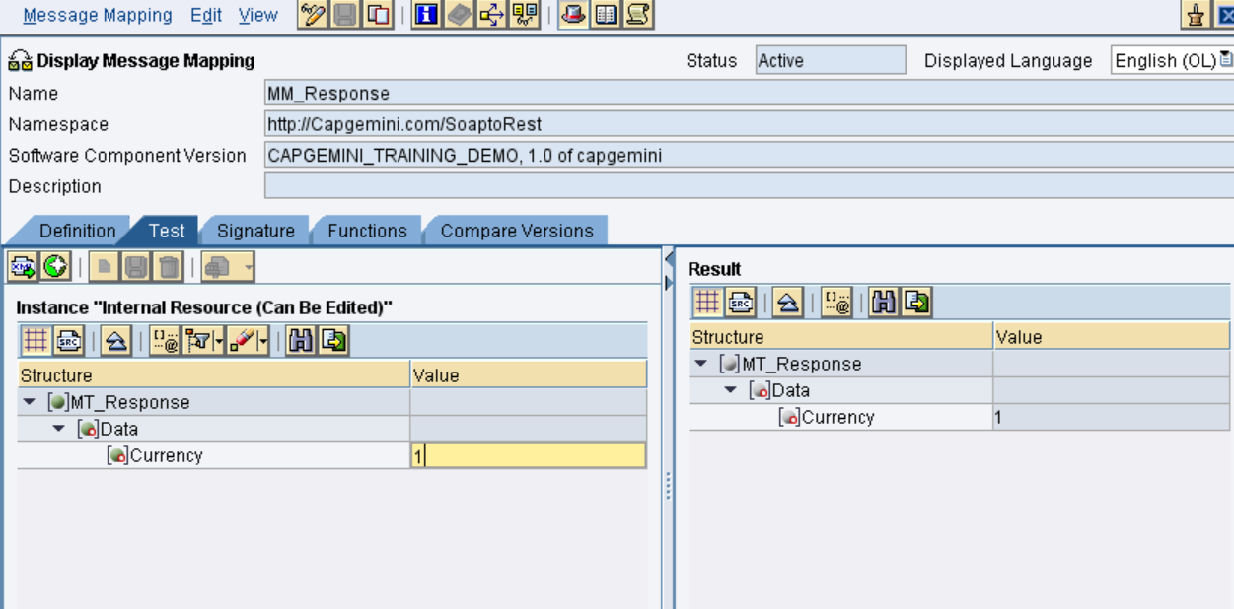

**10. Create the Operation Mapping:**

In OM_Soap_To_Rest, select source interface “SI_Out_Syn” and Target interface “SI_In_Syn” as shown below.

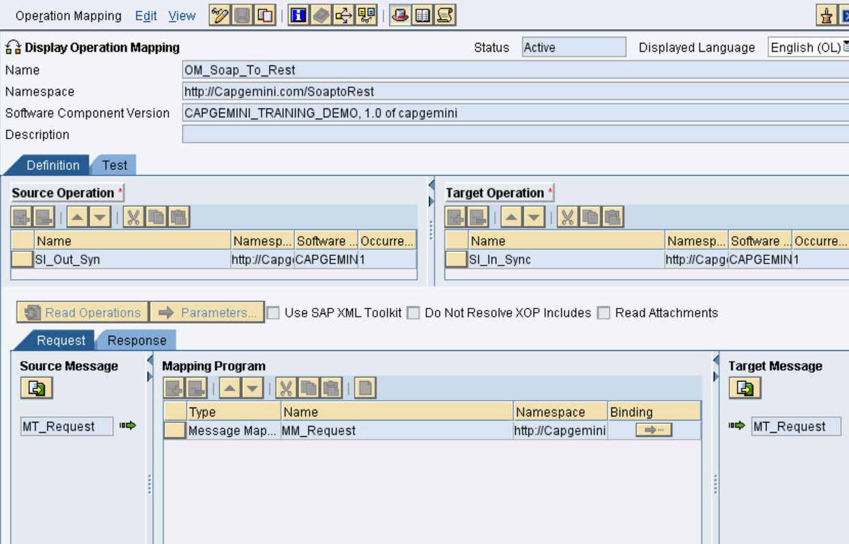

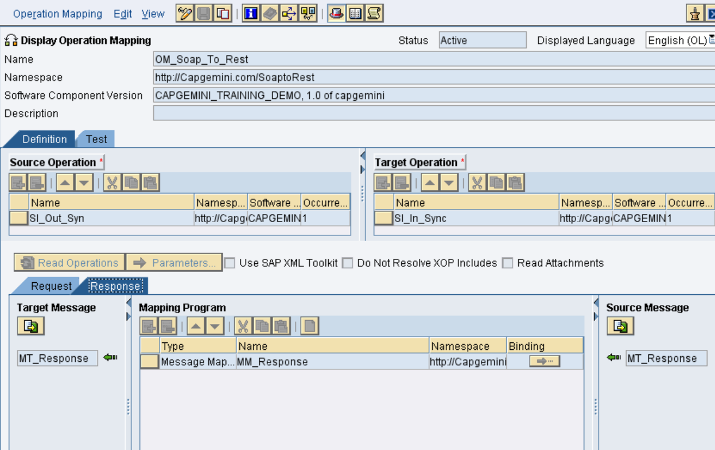

**Configuration:**

**Access to the Process Integration Tools:**

Link provided.

<http://in-mum-solman:50000/dir/start/index.jsp>

**Access Integration Directory:**

Click on the link Integration Builder under Integration Directory. The following screen appears as below



**Create a new scenario:**

Create a new CS in Integration directory with **CS_Soap_To_REST** as shown below with your ID as description.

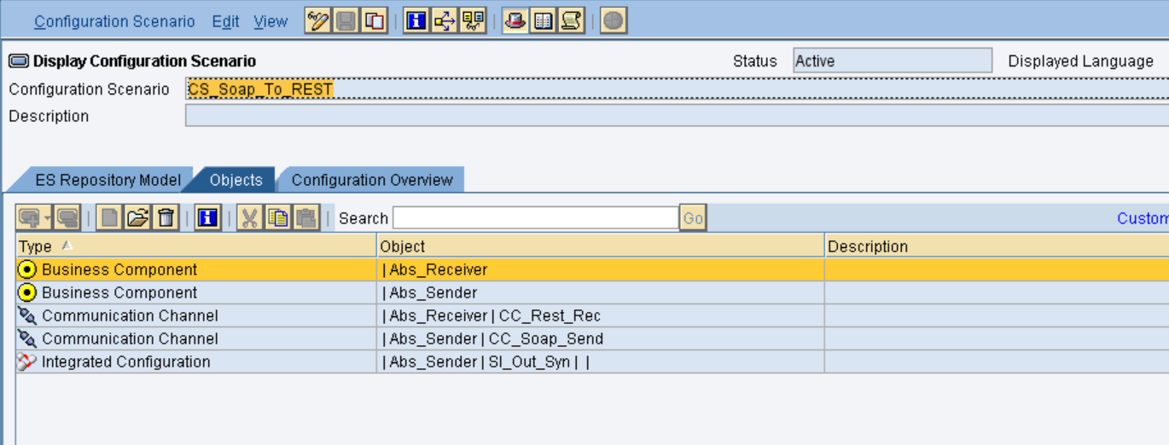

Create a BS for triggering Idoc and BC to receive the file through PO. For now we are using the existing ones.

**Sender BS:**

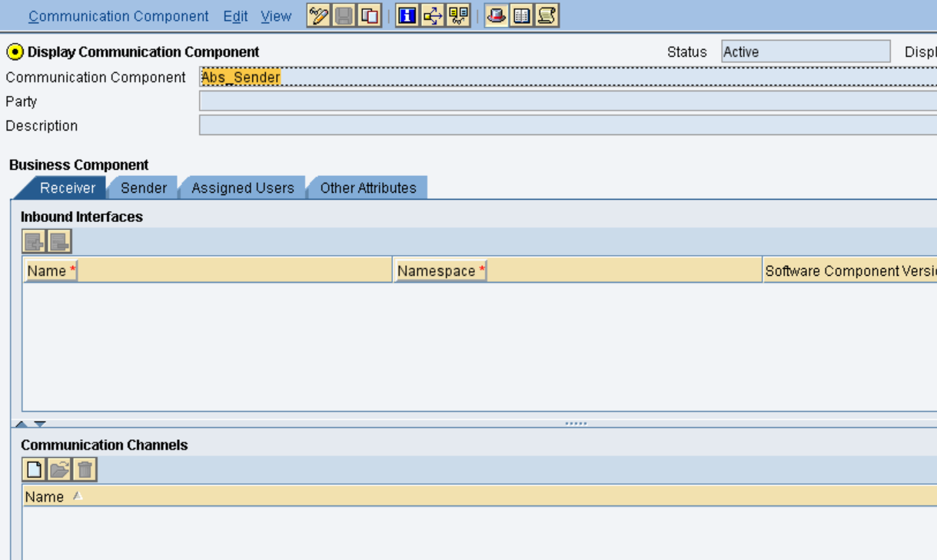

**Receiver BC:**

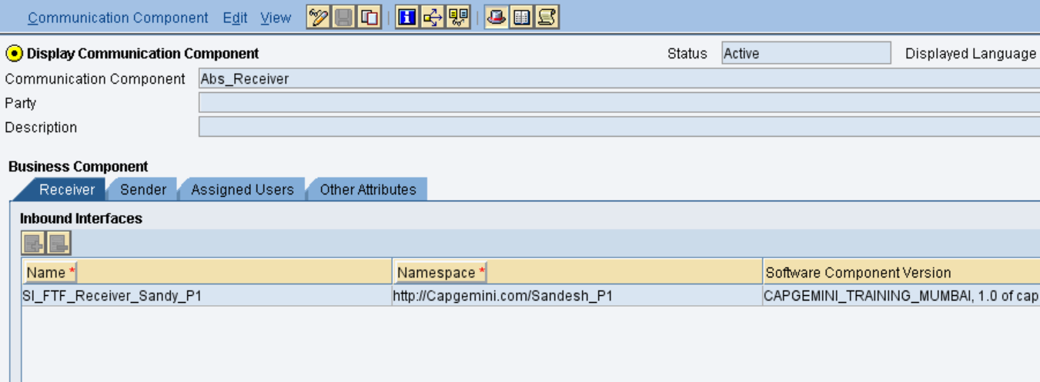

Create a communication channels for both sender and Receiver.

**SOAP sender:**

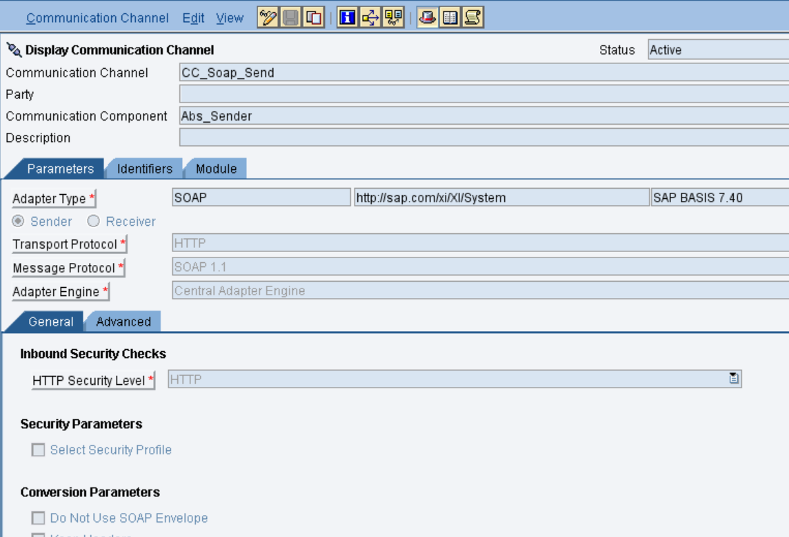

**REST Receiver:**

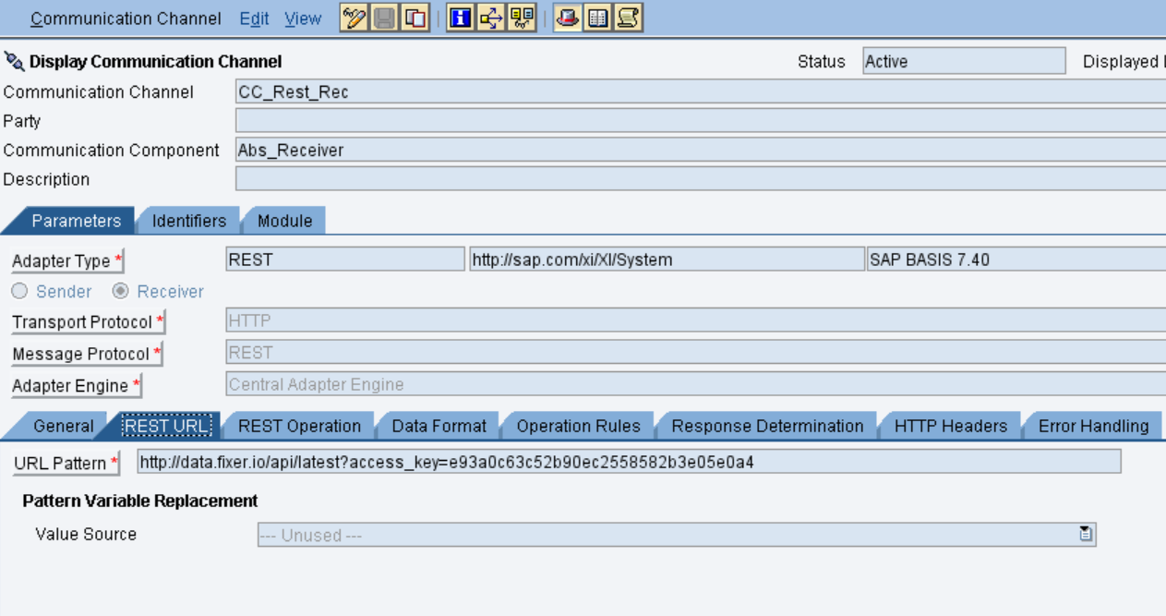

**ICO: Integrated Scenario**

CreateICO as below

